**大数据作业2 HBase**

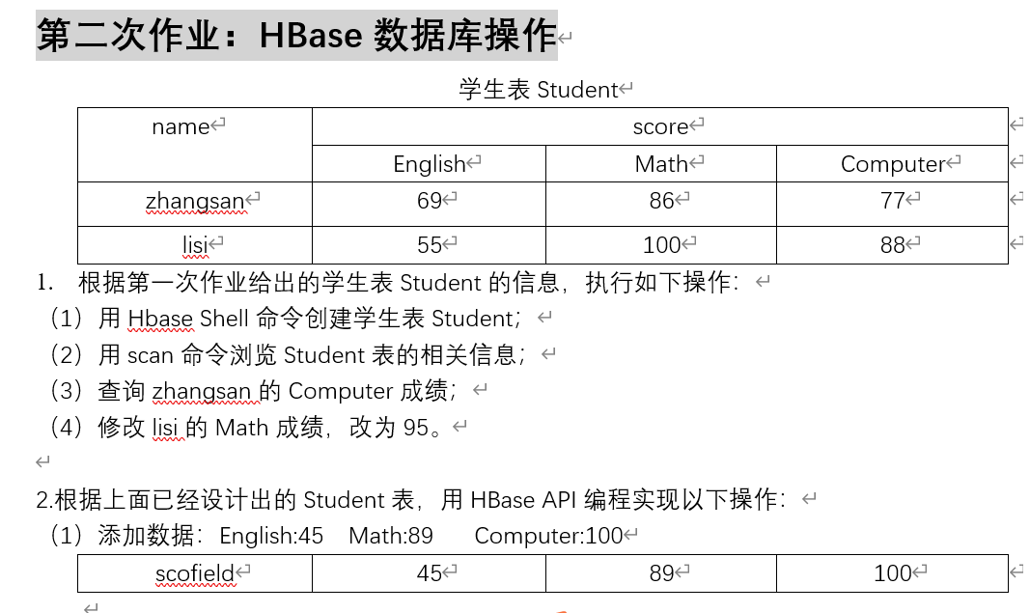

1. (1)

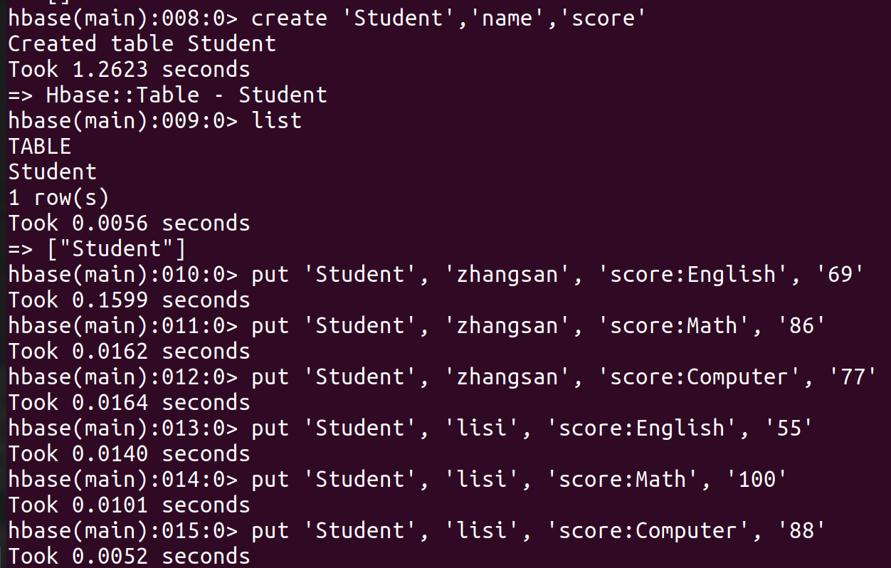

(2)

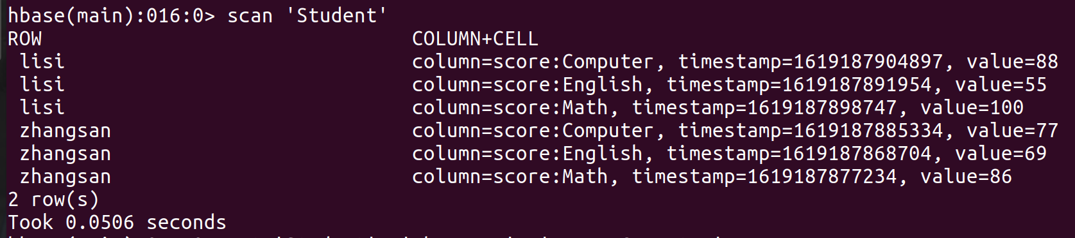

(3)

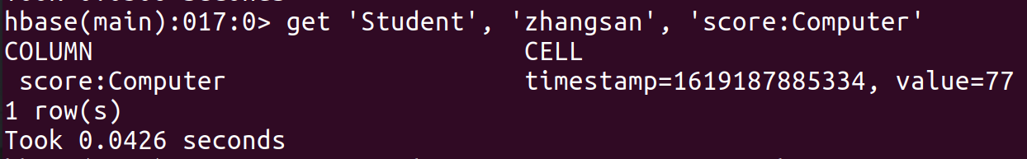

(4)

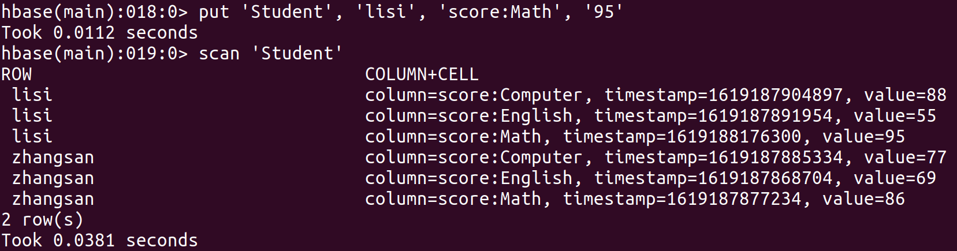

1. (1)

Eclipse insertRow执行前

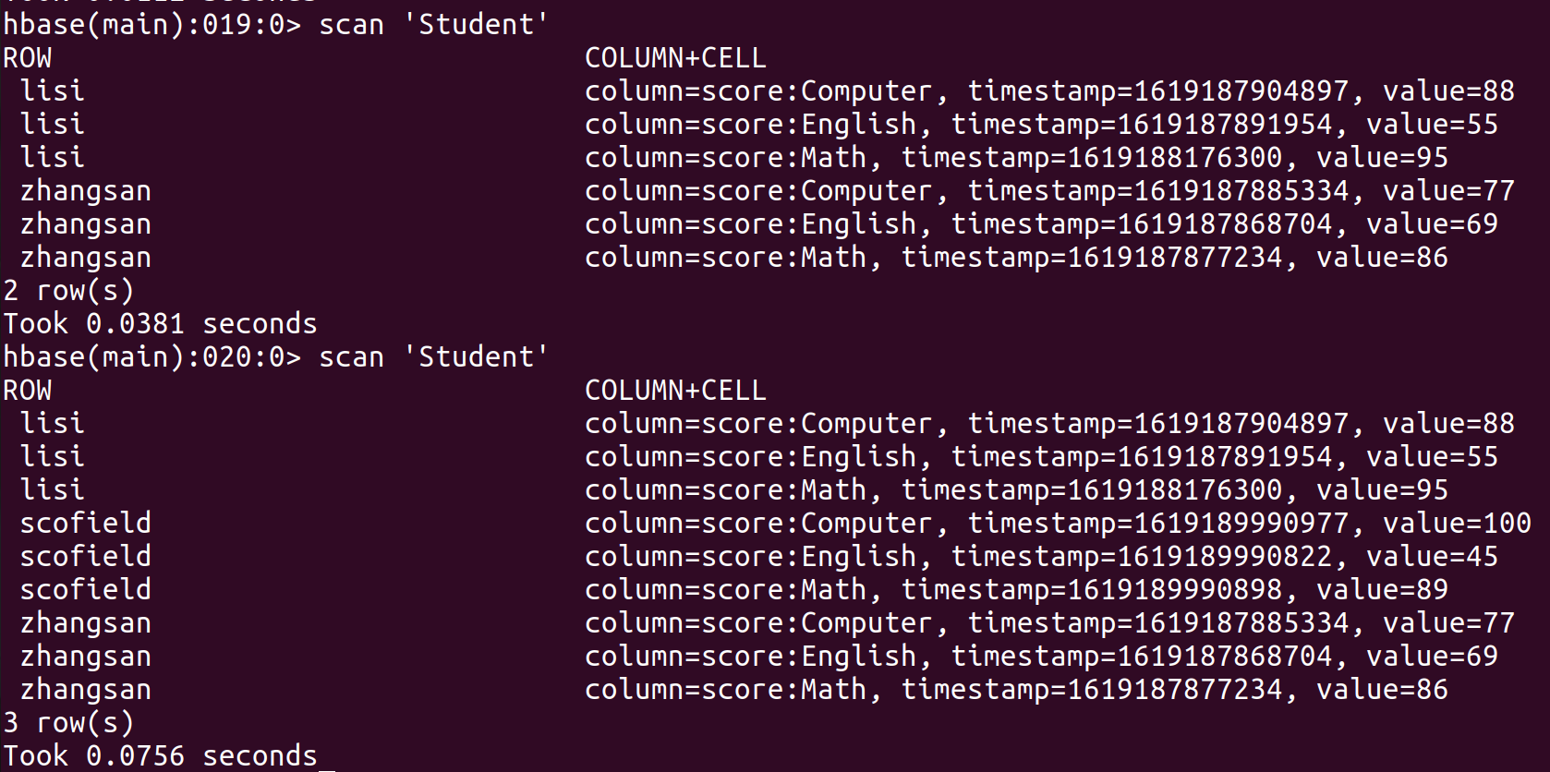

Eclipse insertRow执行后

编程实践：

**import** org.apache.hadoop.conf.Configuration;

**import** org.apache.hadoop.hbase.*;

**import** org.apache.hadoop.hbase.client.*;

**import** java.io.IOException;

**public** **class** HbaseEg{

**public** **static** Configuration *configuration*;

**public** **static** Connection *connection*;

**public** **static** Admin *admin*;

//主函数中的语句请逐句执行，只需删除其前的//即可，如：执行insertRow时请将其他语句注释

**public** **static** **void** main(String[] args)**throws** IOException{

//创建一个表，表名为Score，列族为sname,course

// createTable("Score",new String[]{"sname","course"});

/**插入一行数据：

* put 'Student', 'scofield', 'score:English', '45'

put 'Student', 'scofield', 'score:Math', '89'

put 'Student', 'scofield', 'score:Computer', '100'

*/

*insertRow*("Student", "scofield", "score", "English", "45");

*insertRow*("Student", "scofield", "score", "Math", "89");

*insertRow*("Student", "scofield", "score", "Computer", "100");

System.***out***.println("insert into table success");

}

//建立连接

**public** **static** **void** init(){

*configuration* = HBaseConfiguration.*create*();

*configuration*.set("hbase.rootdir","hdfs://localhost:9000/hbase");

**try**{

*connection* = ConnectionFactory.*createConnection*(*configuration*);

*admin* = *connection*.getAdmin();

}**catch** (IOException e){

e.printStackTrace();

}

}

//关闭连接

**public** **static** **void** close(){

**try**{

**if**(*admin* != **null**){

*admin*.close();

}

**if**(**null** != *connection*){

*connection*.close();

}

}**catch** (IOException e){

e.printStackTrace();

}

}

/**

* 向某一行的某一列插入数据

* **@param** tableName 表名

* **@param** rowKey 行键

* **@param** colFamily 列族名

* **@param** col 列名（如果其列族下没有子列，此参数可为空）

* **@param** val 值

* **@throws** IOException

*/

**public** **static** **void** insertRow(String tableName,String rowKey,String colFamily,String col,String val) **throws** IOException {

*init*();

Table table = *connection*.getTable(TableName.*valueOf*(tableName));

Put put = **new** Put(rowKey.getBytes());

put.addColumn(colFamily.getBytes(), col.getBytes(), val.getBytes());

table.put(put);

table.close();

*close*();

}

}